Development concept for the
EPLDF.KEYBOARD-MONITORING
Provided by ICIG-BS

Author of the document

Name | Role, Department | Date | Signature
Luca Müller | Junior System Engineer Collaboration

Control of the document

Name | Role, Department | Date | Signature
Philip Möller | System Engineer Collaboration

Release of the document

Name | Role, Department | Date | Signature
Sven Locke | CAOU-FY-EFT-TS-AIE-TB

Table of contents
1 Introduction 3
1.1 Aim of the document 3
1.2 Scope of the document 3
2 Description of the requirements 4
3 Roles and responsibilities 5
4 Description of the process 6
4.1 Key monitoring process 6
5 Interfaces 7
6 Expenses 8
7 Document control 9
7.1 Owner of the document 9
7.2 Change history 9
7.3 Document storage 9

Introduction

Aim of the document
The document is a written basis for the development of the application EPLDF.Keyboard-Monitoring. The requirements and delimitations described in this document are binding for the ICIG-BS development team as well as for the clients. The concept describes the necessary information for the new application.
Therefore, the following topics will explain:
- The specific requirements of the application. What should be possible
- The specific processes which describe the procedure of the application include user actions and system actions.
- The effort estimation for the development

Scope of the document
This document focuses on the development of the new EPLDF.Keyboard-Monitoring.

Description of the requirements
The goal is to have a key monitoring application that can detect if a key has been pressed and hold for a specific time. Additionally, it is needed to log whenever the key has been pressed and hold for longer than the specified time.
Currently in the control room, users working at PCs need to react to notifications (e.g., information, warnings, etc.), and each notification must be acknowledged using the F12 key. To make sure that each notification is acknowledged correctly this tool should be used for monitoring of the F12 key.
This application must meet the following requirements:
- Monitoring the defined keys from the configuration file whether a key has been pressed and hold for longer than the defined time.
- The application must be a non-blocking execution on Windows and is not allowed to interrupt other applications. Only the pop up is allowed to interrupt the user.
- When a key has been pressed and hold for longer than the defined time, the user must be informed with a pop up. The pop up must always go to foreground to interrupt from further work in any other application. If the user closed the pop up and keeps pressing and holds the key the pop up will appear again.
- When a key has been pressed and hold for longer than the defined time, the application must log the event in a file with the following information
  - Date and Time
  - Computer Name
  - Which key has been pressed and for what time
- The application must be available as “.exe” file to be selected for auto-start in Windows.

Roles and responsibilities
Table 1: Roles and responsibilities
Role | Description
User | The employees working in the control room, at the PCs and reacting to notifications (e.g.: information, warning…)
Admin | The employee who wants to monitor how often the defined keys have been pressed and hold for the defined time.

Description of the process

Key monitoring process
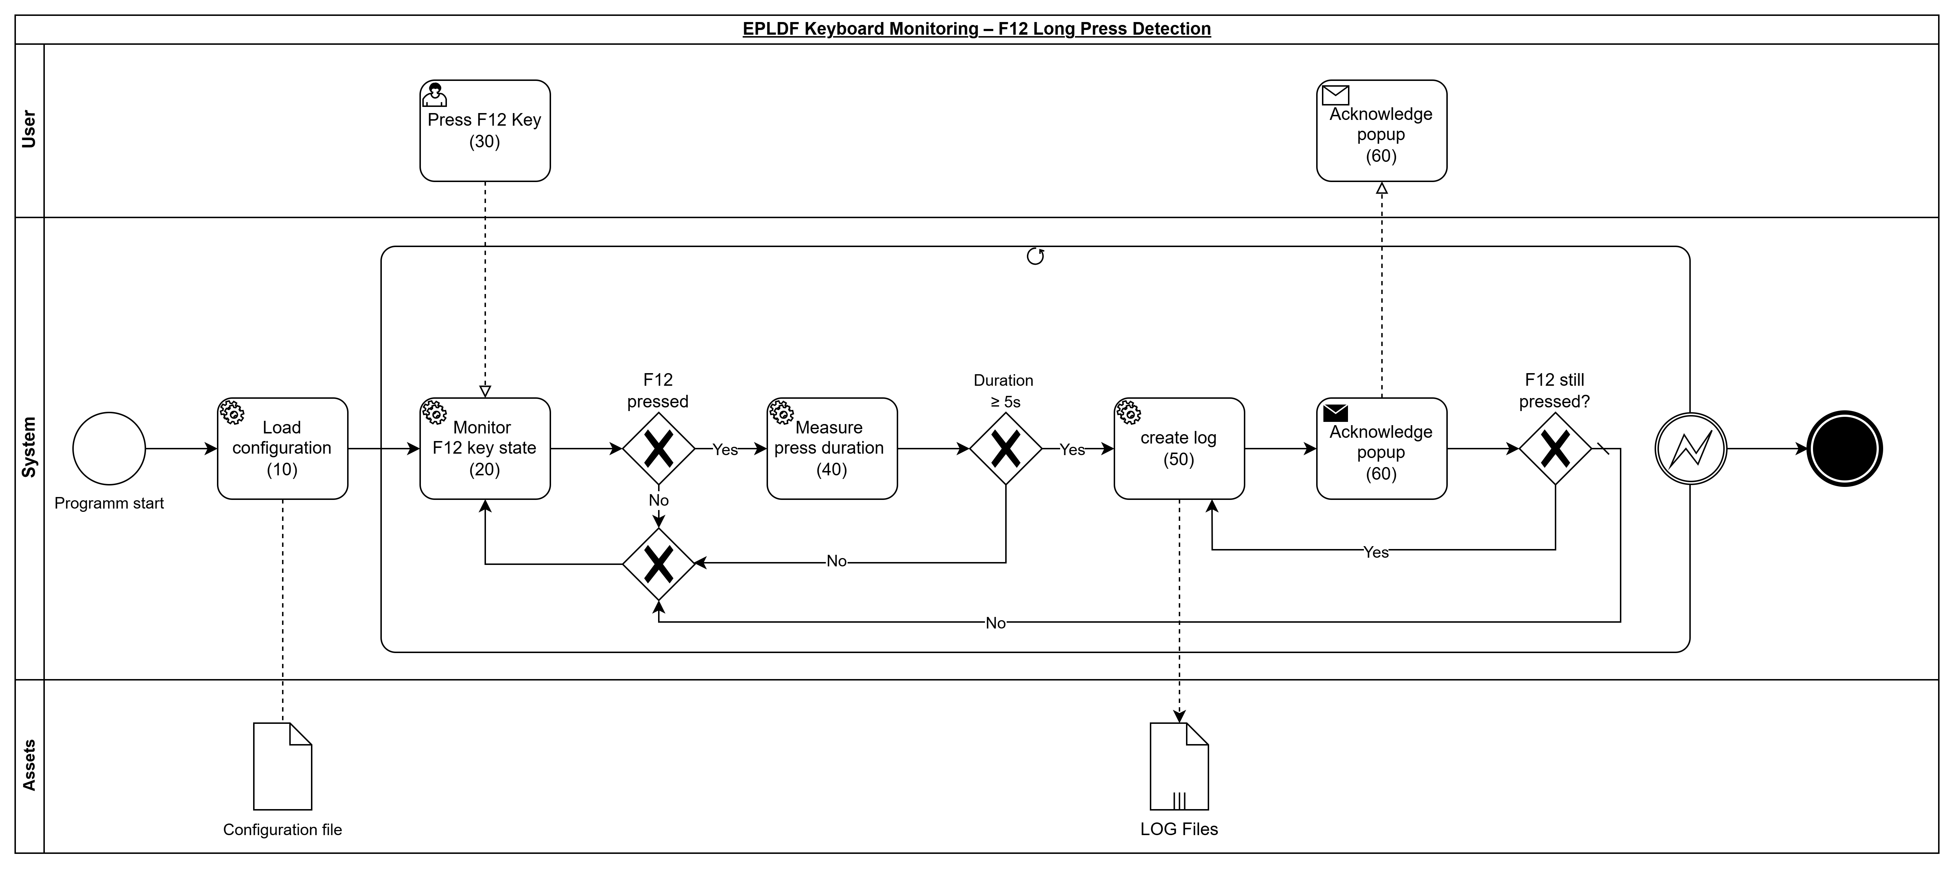
Figure 1: EPLDF keyboard monitoring – F12 long press detection
This process will start automatically when the program is started on the system.
First, the application will load the configuration file (10). Based on the configuration, the defined key, in this case the F12 key, will be monitored continuously (20).
When the user presses the F12 key (30), the system checks whether the key remains pressed. If the F12 key is not pressed continuously, the process returns to monitoring the key state.
If the F12 key is pressed, the application will measure the press duration (40). When the key has been pressed for 5 seconds or longer, a log entry with the relevant metadata will be created (50).
After the log has been created, the user will be informed by a popup message on the PC (60). The user must acknowledge this popup.
After the popup has been acknowledged, the system checks whether the F12 key is still pressed. If the key is still pressed, the process continues directly with creating another log entry and showing the popup again. If the key is no longer pressed, the process returns to monitoring the key state.

Interfaces
The application will use the following interfaces:
- Windows SDK Build tools
- Windows App SDK

Expenses
Project phase | Estimate
Concept development | 0.5 PD
Development | 1 PD
Testing | 0.25 PD
Creating documentation | 1 PD
Coordination with customer / PM | 0.25 PD

Document control

Owner of the document
ICIG Business Services is the owner of this document and performs an annual review of this document. The Enterprise Application department is responsible for updating this document as required.

Change history
The history of the document and the changes made to previous versions of this document are listed in the table below:

Date | Version | Author | Reviewer | Changes
03.07.2024 | 1.0 | Luca Müller | See reviewer at the top | Creation of the document.

Document storage
This is stored centrally in the Microsoft team in the Enterprise Application department.

